

Fuzzy Logic Homework3

Digit recognition rule-base system

Instructed by Dr.Tahayori

Reza Tahmasebi

saeed77t@gmail.com, Stu ID: 40160957

Table of Contents

1 About the project 3

2 The project flow 3

2.1 Feature extraction 3

2.2 Feature fuzzification 4

2.3 Extract rules from the dataset. 7

2.4 Use rule-based system 8

2.5 Predict the results 8

3 Results 9

# About the project

In this project, we have a dataset containing digit handwriting; the project aims to create a fuzzy rule-base system based on Mamdani's implication to detect the digits.

# The project flow

The project contains a few steps: feature extraction, making fuzzy sets, extracting rules, using a rule system, predict the results.

## Feature extraction

In this project, two methods have been used to extract features from images .

1. Principle component analysis (PCA)
2. Linear discriminant analysis (LDA), known as FLDA.

In both methods, we scaled our dataset in a way to prevent negative numbers (the absolute value of the minimum of features was added to each feature)

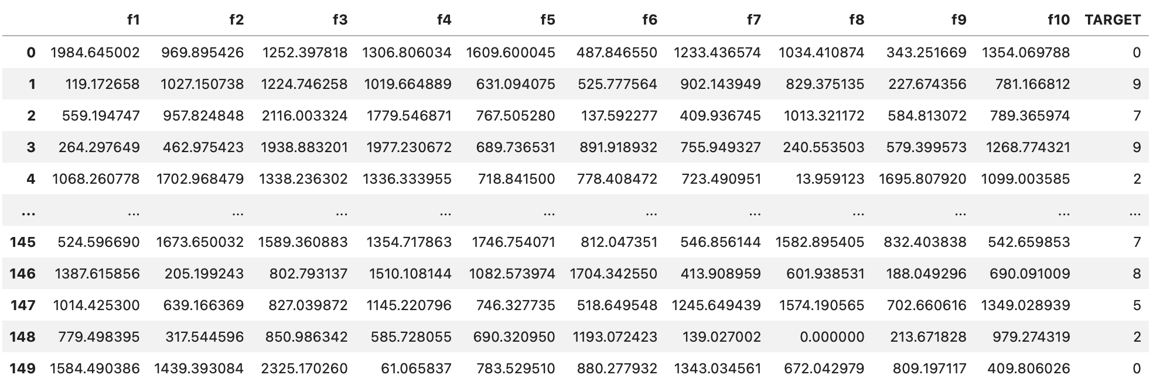

Example of PCA feature extraction on the dataset

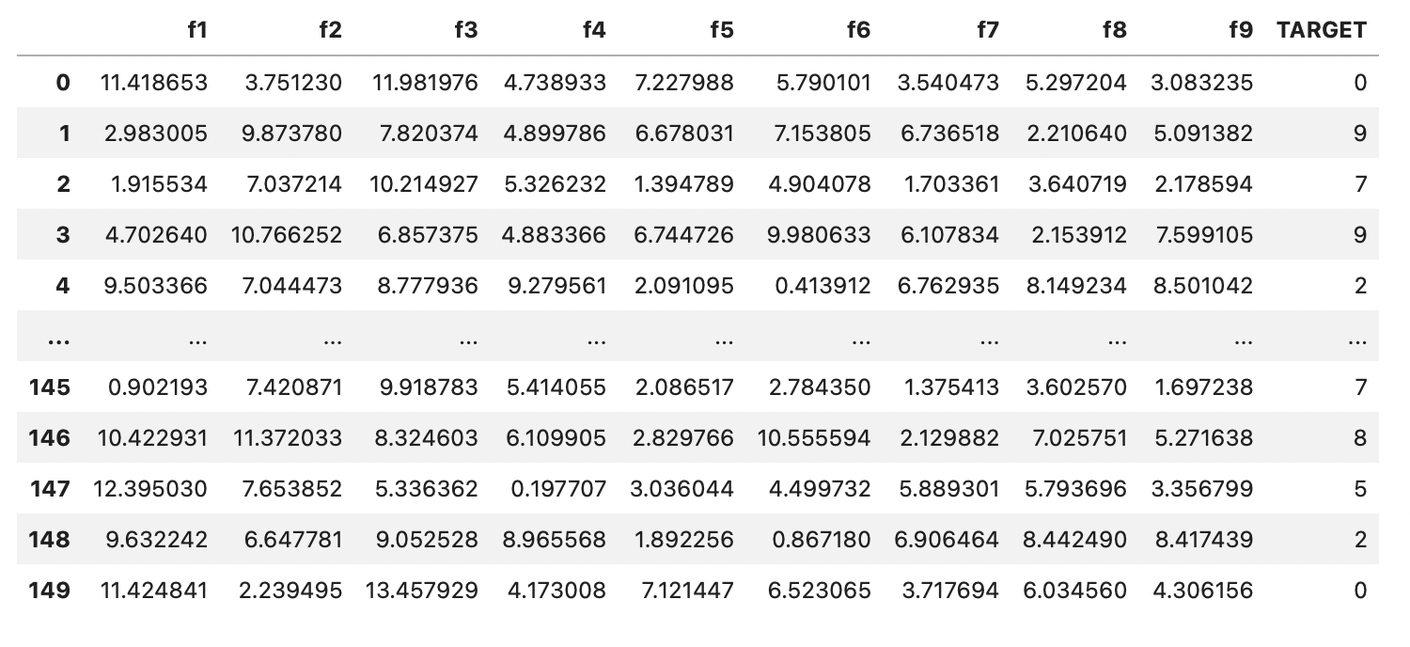

Example of FLDA feature extraction on the dataset

## Feature fuzzification

To create our fuzzy sets from each feature, first, we calculate the domain of each feature; then, with the help of the ***skfuzzy*** library, we define each feature as our antecedent. With the *trimf* method from the library, we create the triangulated fuzzy sets.

The histogram of each feature helped to understand each feature's ‘normal,’ ‘low,’ and ‘high’ range.

The plots below show each image's histogram and fuzzy sets.

The *Consequent* method from the ***skfuzzy*** library was used to fuzzy-fie the labels.

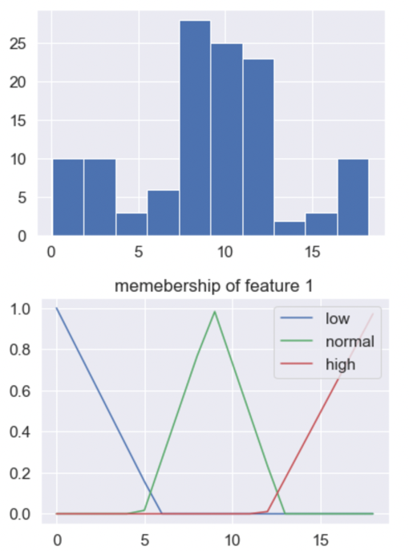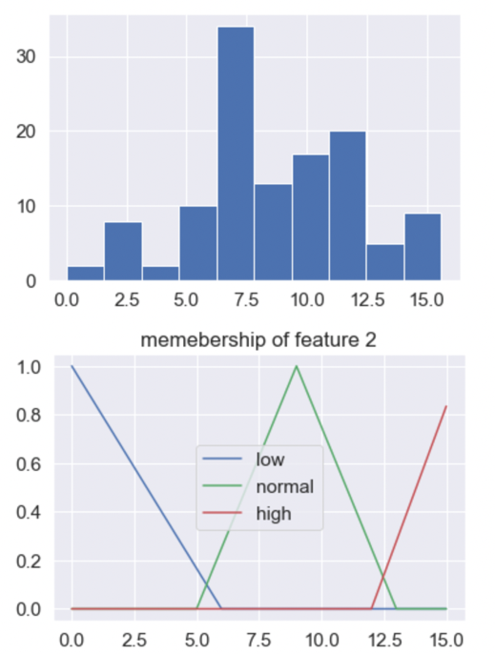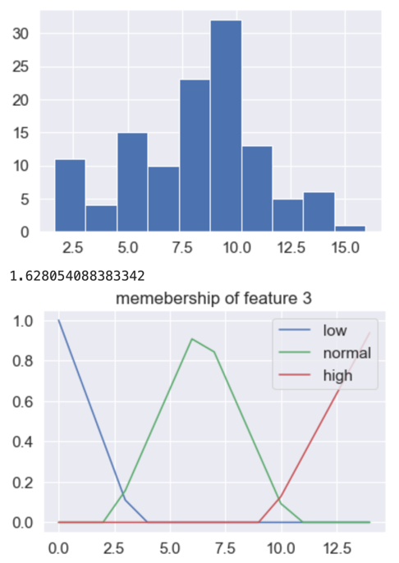

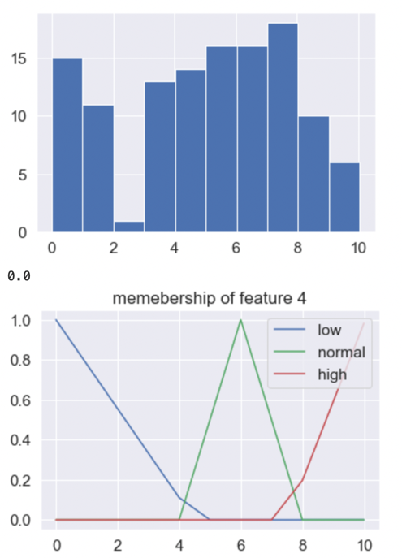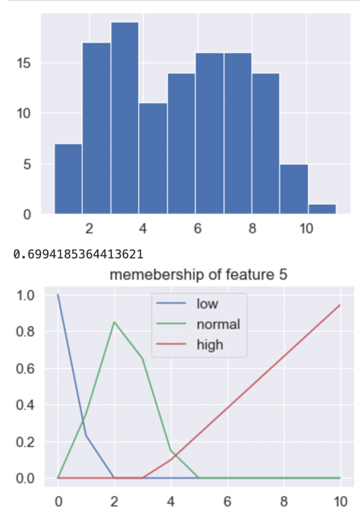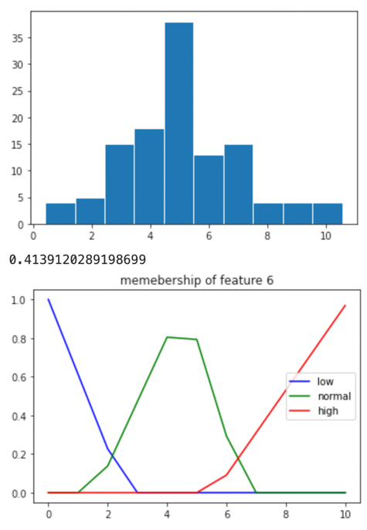

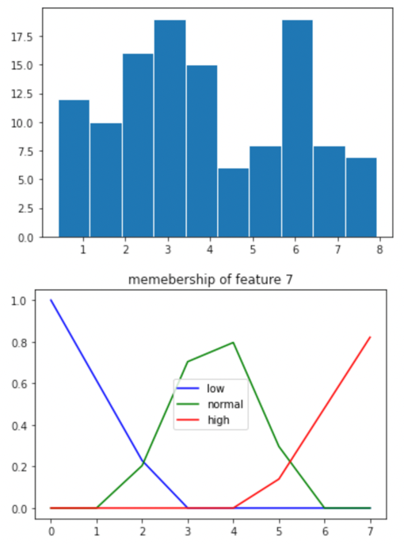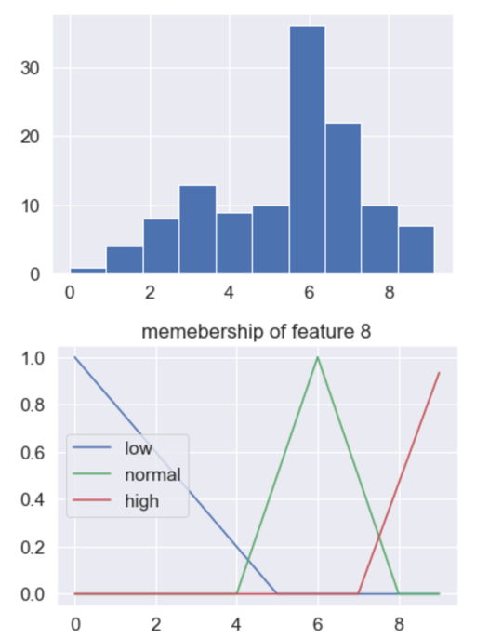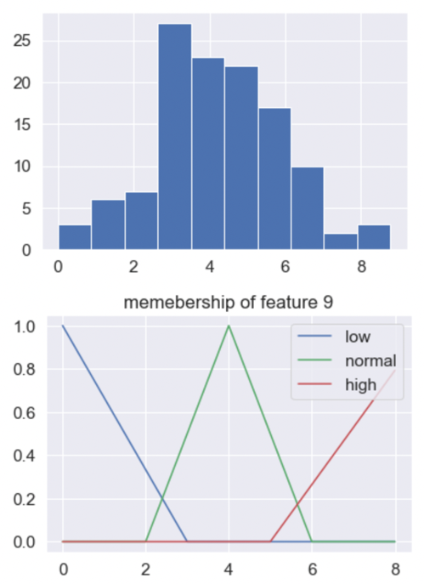

Features fuzzy sets

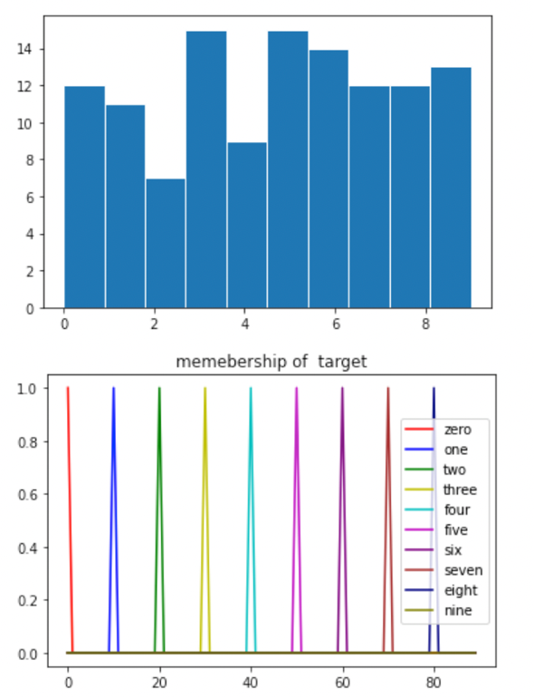

Labels fuzzy sets

## Extract rules from the dataset.

We used all of our training data to extract rules; we used the *interp_membership* method from the library to calculate the degree of each feature in low, normal, and high ranges of its fuzzy set, then we used the *argmax* method to define each feature of the training data sets belongs to what range.

The output of the cycle is like the figure below.

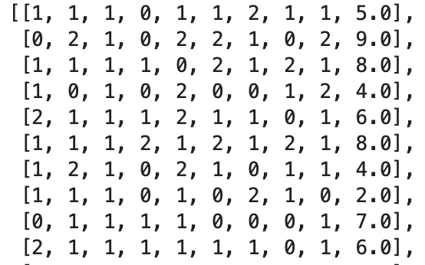

The output of the rule extraction cycle

With the ***defineRulec*** function, we replace each of the numbers ( 0, 1, 2 ) with ‘low,’ ‘normal,’ and ‘high,’ respectively.

And we use the ***setrules*** function to create the rules in a way that we can use in our system.

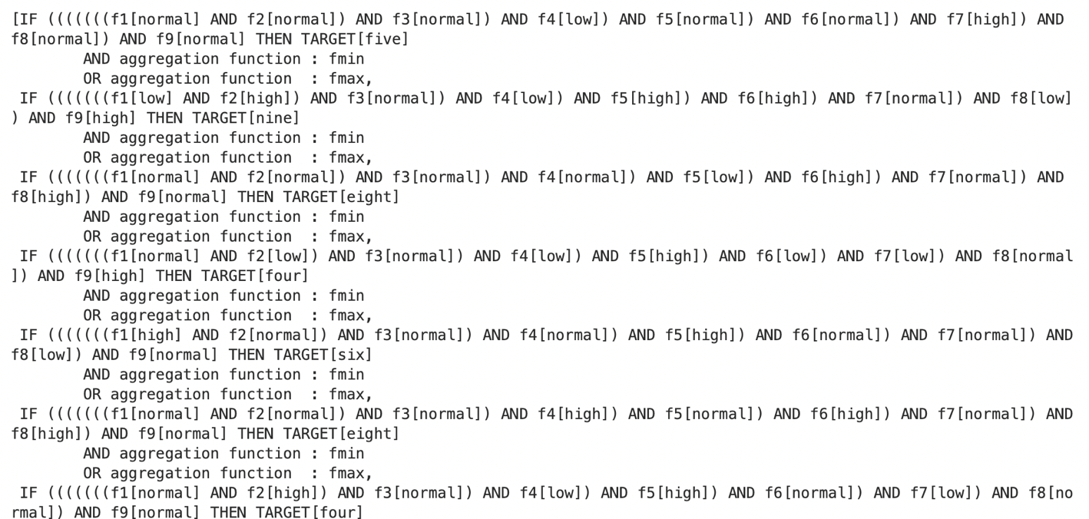

Example of extracted rules

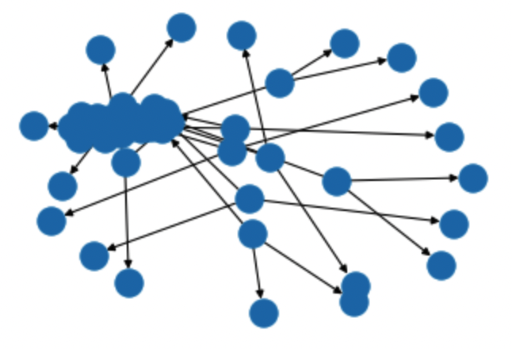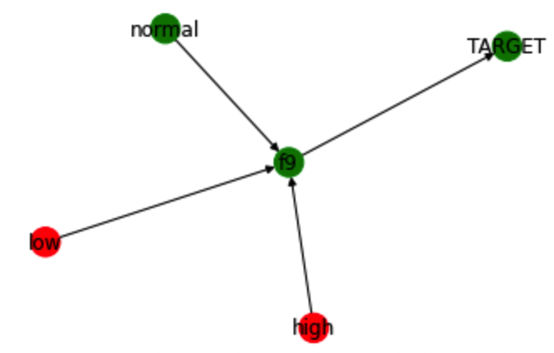

A graph view of a single rule from two different sides.

## Use rule-based system

The rules created in the previous step were passed into the *ControlSystem* method from the library, got the result back, and then given into the ControlSystemSimulation method, which returns the simulations.

## Predict the results

With a for loop on our test dataset, we wet our inputs of the test dataset equal to our model features and

With *compute* method, we got back our results*.*

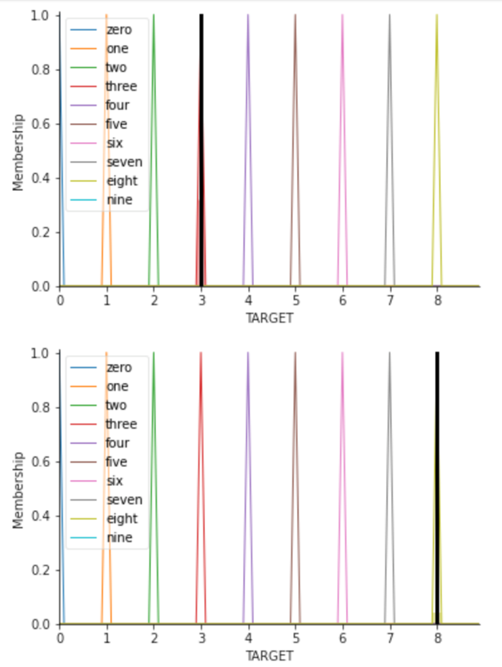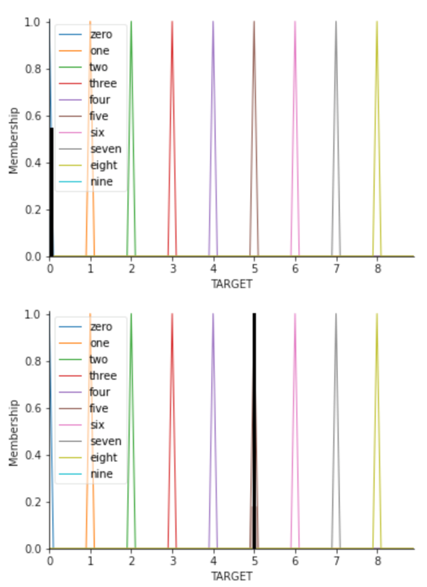

Prediction plots

And after that, with the *prediction* method, we sort and organize the output of the fuzzy system, and then with the *accuracy_score function, calculate* the system's accuracy.

# Results

The project has been run on two different feature sets,

1. PCA feature sets
2. FLDA feature sets

The accuracy of the PCA feature set could have been better, and it was about 10% to 20%.

But the accuracy of the FLDA features set was ok, and it was about 60% to 80%; in the lastest run, I got 83.33% accuracy.

# Type2 fuzzy systems

This part used ***pyit2fls***  to create type2 fuzzy sets with each feature's mean and standard deviation.

The pictures below are fuzzy sets, and join and meet them.

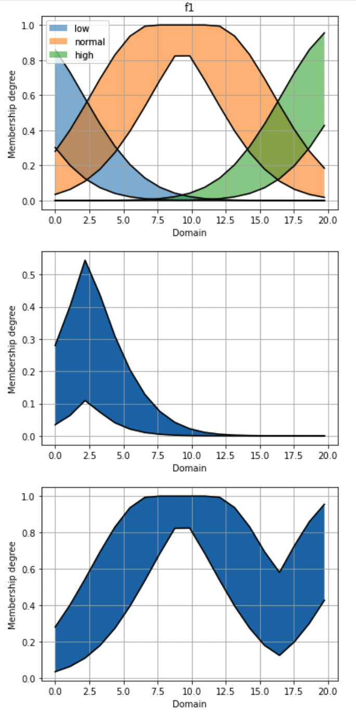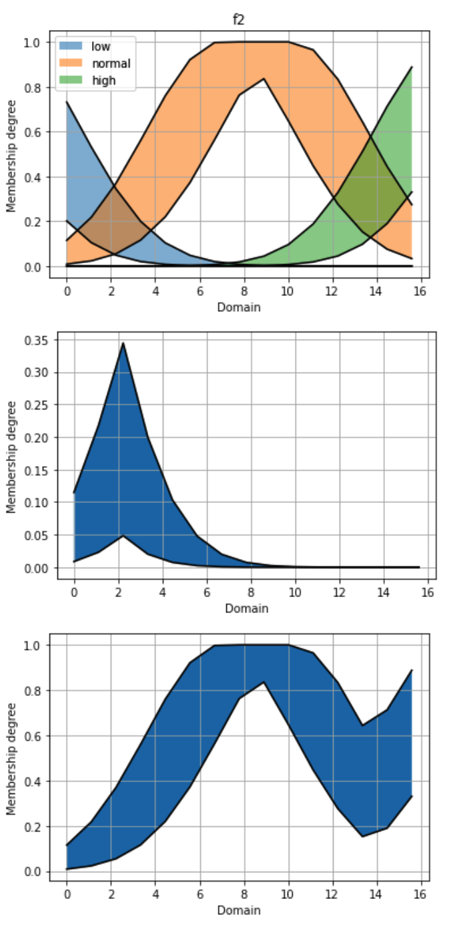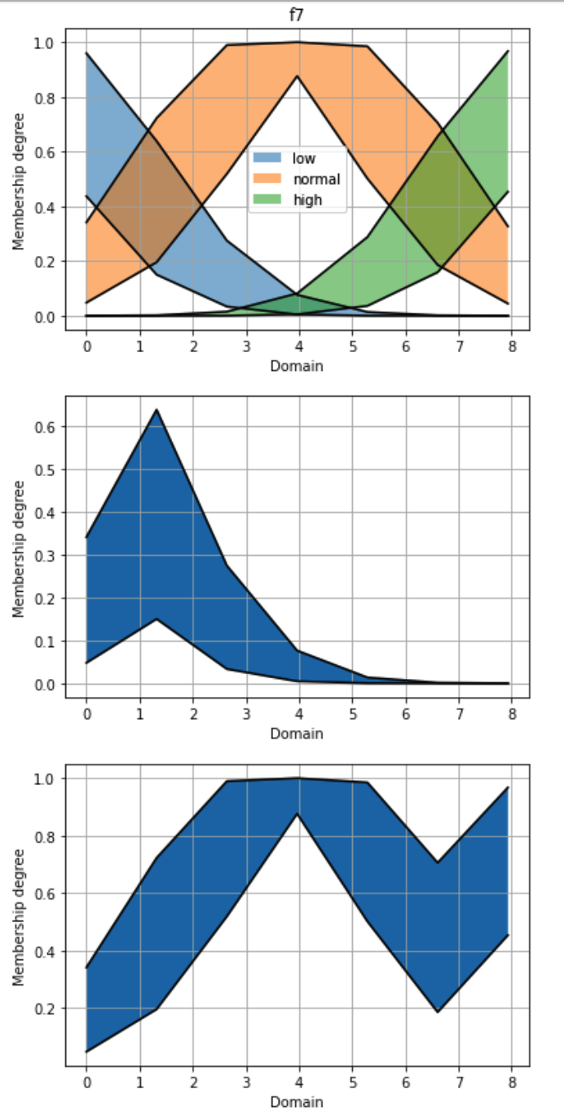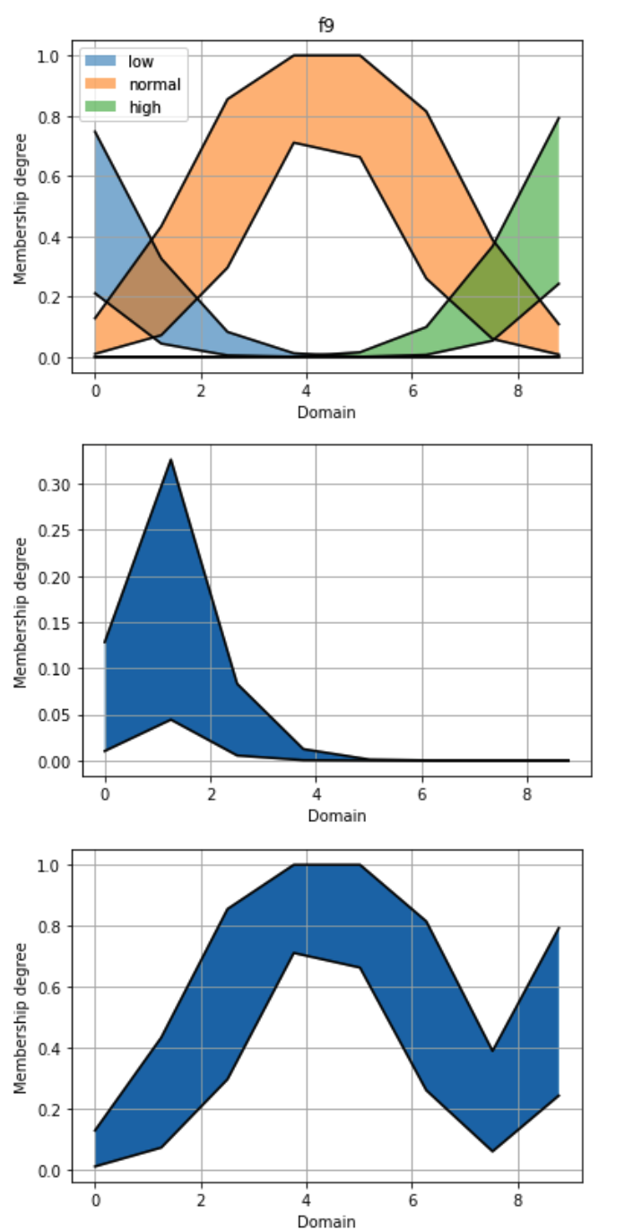

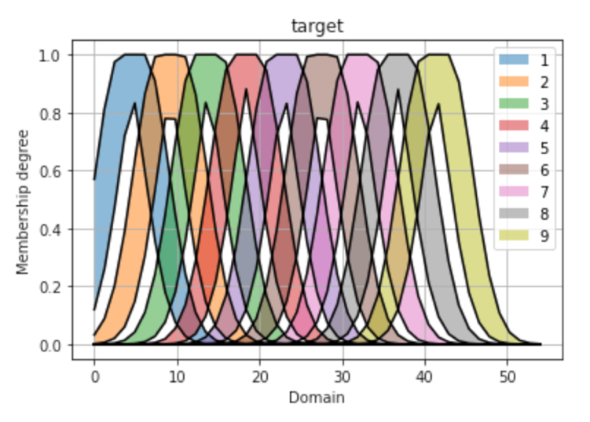

Type2 labels fuzzy sets

## Rules

From the *Mamdani* class, we create an object, then with the *add_input_variable* method, we can define our inputs, and then with the *add_output_variable approach*, we represent our targets.

We can use the *add_rule*  method to add rules to our system . our rules will be like this:

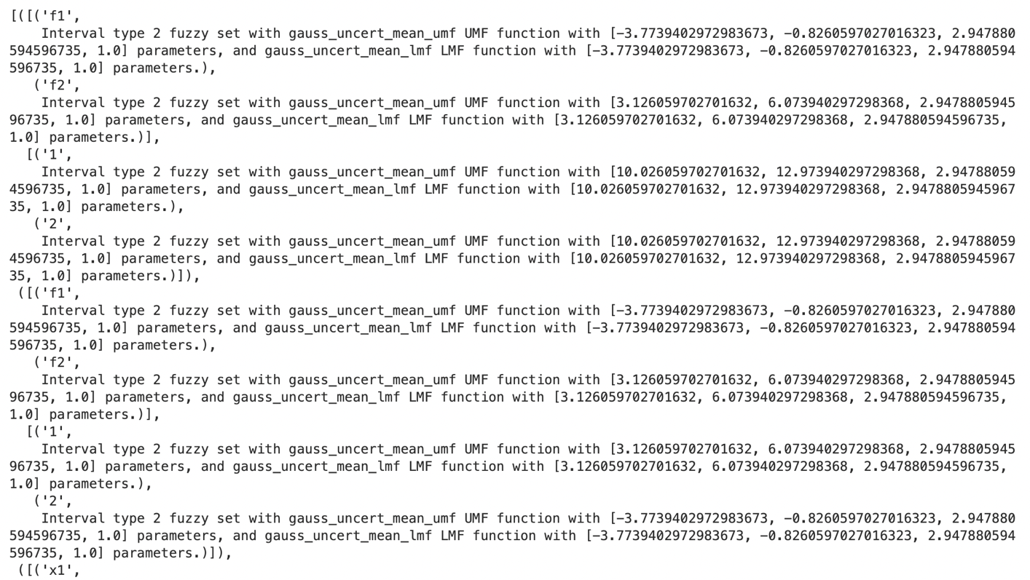

Example of rules in type2 systems